DNS A Record

🅰️ What is a DNS A Record?
# Source: Chatgpt (GPT-5-Mini) at [1/18/2026]
A DNS A Record (short for Address Record) maps a domain name to its corresponding IPv4 address.
🧠 It’s like the phone book entry that tells the internet:
"For this website name, here’s the IPv4 address to connect to."

🔍 Details of A Record
# Source: Chatgpt (GPT-5-Mini) at [1/18/2026]
- Purpose: Translates a domain name (e.g., example.com) into a 32-bit IPv4 address (e.g., 93.184.216.34).
- Format:
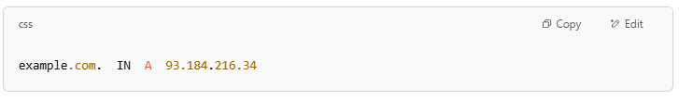
example.com. IN A 93.184.216.34

- Used for: Directing web browsers and other clients to the right server using IPv4.

🌐 Why is the A Record Important?
# Source: Chatgpt (GPT-5-Mini) at [1/18/2026]
When you type www.example.com in your browser, the DNS system looks up the A record to find the IPv4 address so your browser knows where to send the request.

🔁 Relation with Other Records
# Source: Chatgpt (GPT-5-Mini) at [1/18/2026]
- AAAA record: Similar to A record but maps to an IPv6 address instead of IPv4.
- CNAME record: An alias that points one domain to another domain’s A record.

Example
# Source: Chatgpt (GPT-5-Mini) at [1/18/2026]
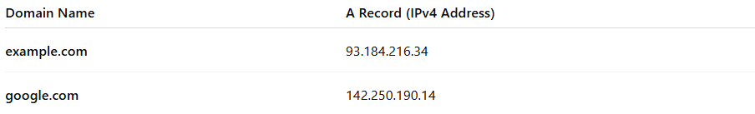

Domain Name | A Record (IPv4 Address)
example.com | 93.184.216.34
google.com | 142.250.190.14

✅ Summary
# Source: Chatgpt (GPT-5-Mini) at [1/18/2026]
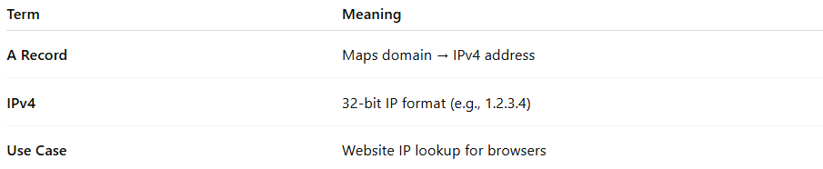

Term | Meaning
A Record | Maps domain → IPv4 address
IPv4 | 32-bit IP format (e.g., 1.2.3.4)
Use case | Website IP lookup for browsers

